How to align the FLIM image to the widefield image.

Acquire a widefield image and use the grid function of the viewer to place a 5x5 grid, say, on the image.

Switch to laser scanning mode for FLIM and acquire an image and place a similar grid on this image.

The position of the FLIM image can be changed with the Offset control on the scanner settings panel.

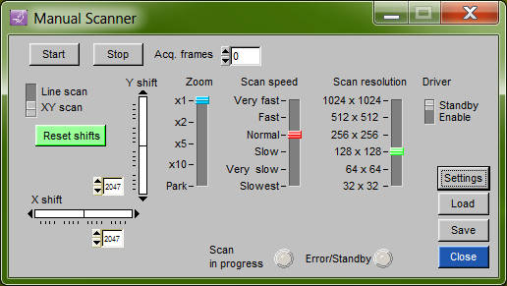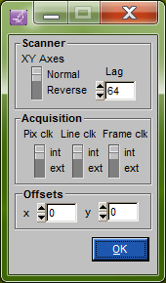

Use the x and y offsets to move the FLIM image whilst in Live Acquire.
When finished be sure to click Save to store the new values.

If the offsets used are too large (more than 1024?) then the image field of view may become limited. Then the scanners must be physically moved into better alignment by ‘a qualified person’.

If the image needs to be scaled (made larger or smaller) to match the widefield image, then the hardware controls must be used on the scanner board inside the scanner control box. Use a small screwdriver to carefully turn the two lower controls (pots) while Live Acquire is running.

